Project 3
Demo Project:
Complete CI/CD with Terraform

Technologies used:
Terraform, Jenkins, Docker, AWS, Git, Java, Maven, Linux, Docker Hub

Project description:
Integrate provisioning stage into complete CI/CD Pipeline to automate provisioning server instead of deploying to an existing server:
- Create a SSH Key Pair
- Install Terraform inside Jenkins container
- Add Terraform configuration to application’s git repository
- Adjust Jenkinsfile to add ‘provision’ step to the CI/CD pipeline that provisions EC2 instance
- So the complete CI/CD project we build has the following configuration:
- CI step: build artifact for Java Maven application
- CI step: Build and push Docker image to Docker Hub
- CD step: Automatically provision EC2 instance using TF
- CD step: Deploy new application version on the provisioned EC2 instance with Docker Compose

This project involves integrating Terraform into a complete CI/CD pipeline to automate the provisioning of infrastructure rather than deploying to pre-existing servers. The process begins by creating an SSH key pair and installing Terraform within a Jenkins container. Terraform configuration files are added to the application's Git repository, and the Jenkinsfile is adjusted to include a new "provision" step. This step automates the provisioning of an EC2 instance on AWS as part of the deployment process. The CI/CD pipeline is structured as follows:
- CI Stage: Build the Java Maven application artifact.
- CI Stage: Build a Docker image for the application and push it to Docker Hub.
- CD Stage: Automatically provision an EC2 instance using Terraform.
- CD Stage: Deploy the new application version on the provisioned EC2 instance using Docker Compose.

What I've Learned:
- How to integrate Terraform into a CI/CD pipeline for automated infrastructure provisioning.
- Setting up and managing a complete CI/CD pipeline with Jenkins, from building to deployment.
- The use of Terraform for infrastructure-as-code to provision EC2 instances on AWS.
- Managing application deployment with Docker Compose on a freshly provisioned server.
- How to adjust Jenkinsfile configurations to incorporate infrastructure provisioning steps.
- The importance of automation in streamlining the deployment process and reducing manual intervention.
- Utilizing Docker Hub for storing and managing Docker images within the CI/CD workflow.

We'll start off from what we had in project 1. We simply need to modify the Jenkinsfile to have these stages:

- Build artifact for Java Maven application → Already done
- Build and push Docker image to Docker Hub → Already done
- Automatically provision EC2 instance using Terraform.
- Deploy new application version on the provisioned EC2 instance with Docker Compose

We do not need to increment the app version (in pom.xml) every time we run the pipeline. However, it is useful to have a stage in which we check the version of the app and build number, in order to generate a name for the image that includes the app's version.

The Jenkinsfile and terraform file have been prepared in this repository (under the jenkins-terraform branch):
https://gitlab.com/etiron/java-maven-app/-/tree/jenkins-terraform?ref_type=heads

Create Key Pair
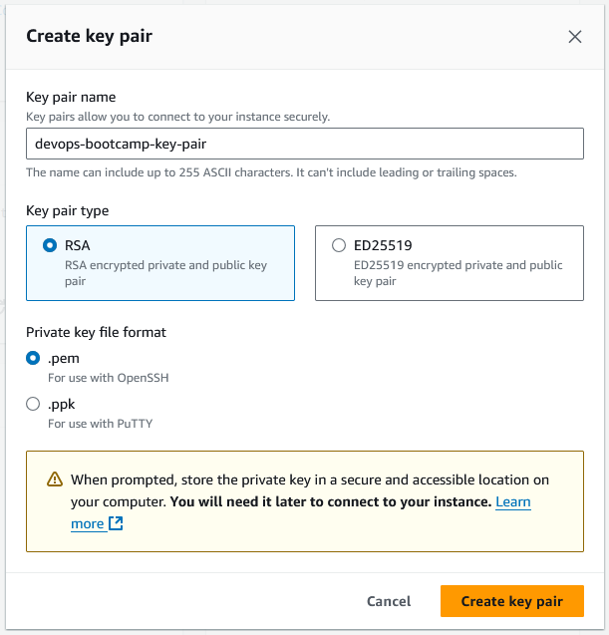
Download the pem file and copy it into the Jenkins container so that it is available to Jenkins. We also need to change its owner and permissions because ssh complains if the key is not correctly secured:

docker ps # Get container id for next command
docker cp "devops-bootcamp-key-pair.pem" 8114c72b2a66:/var/jenkins_home/.ssh/key.pem

docker exec -u 0 -it 8114c72b2a66 bash # Enter container

chown jenkins:jenkins /var/jenkins_home/.ssh/key.pem

chmod 400 /var/jenkins_home/.ssh/key.pem

Add Jenkins job
[Do this on Chrome. Jenkins is buggy on Firefox and some menus don't work properly]
Jenkins GUI → Create job: name java-app-EC2, type Pipeline
Configure it with 'Pipeline script from SCM'.
Add the repository url: https://gitlab.com/redjules/java-maven-app.git
Add the credentials from GitLab (with ID gitlab-credentials).
Branch: */jenkins-terraform

Script path: Jenkinsfile

Prepare DockerHub credentials
Register on DockerHub and add your credentials in Jenkins:
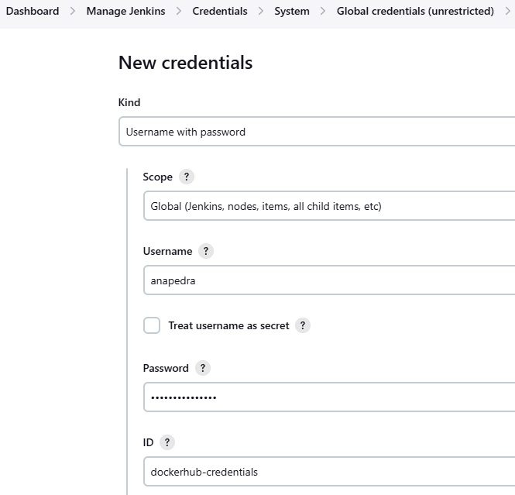

Prepare Terraform files
We've created the required Terraform files in the 'terraform' folder. When the pipeline commits the code, it will be able to access the folder with dir(terraform) and execute terraform commands.

Prepare AWS credentials
Terraform will need to connect to AWS. To configure the credentials, we first install this plugin:
Dashboard > Manage Jenkins > Plugins > Install 'AWS Credentials'
Add CLI credentials for an AWS user:
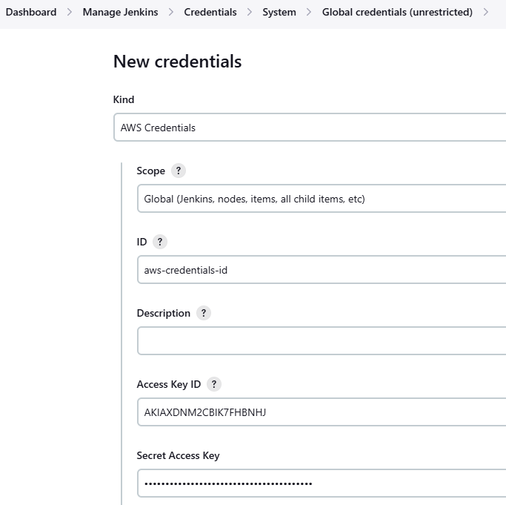

Install Terraform in Jenkins container
docker ps # Get container id for next command
docker exec -u 0 -it 8114c72b2a66 bash
apt update && apt install wget
apt update && apt install -y lsb-release && apt-get clean all
wget -O- https://apt.releases.hashicorp.com/gpg | gpg --dearmor -o /usr/share/keyrings/hashicorp-archive-keyring.gpg

echo "deb [signed-by=/usr/share/keyrings/hashicorp-archive-keyring.gpg] https://apt.releases.hashicorp.com $(lsb_release -cs) main" | tee /etc/apt/sources.list.d/hashicorp.list

apt update && apt install terraform

Results
The pipeline now finishes successfully:
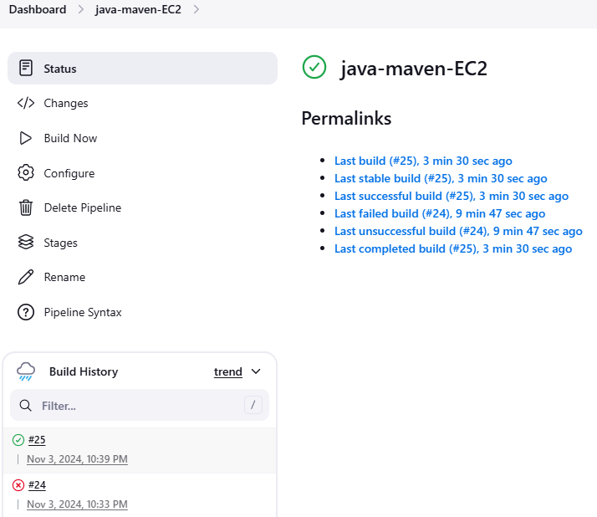
The image is being pushed to Docker Hub:
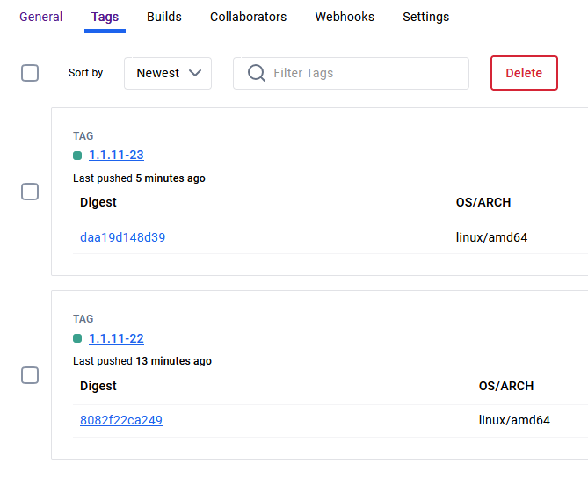
The EC2 instance is created:
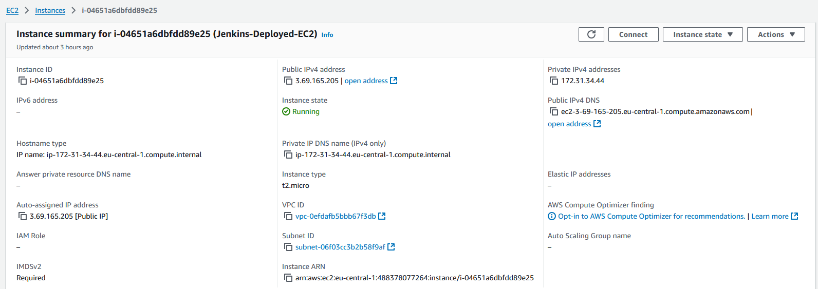
And we can visit the application at the instance's public IP:
